Outline for OCNMS paper. 6/1/2017

Success and succession in species recoveries
Figures & Analyses:
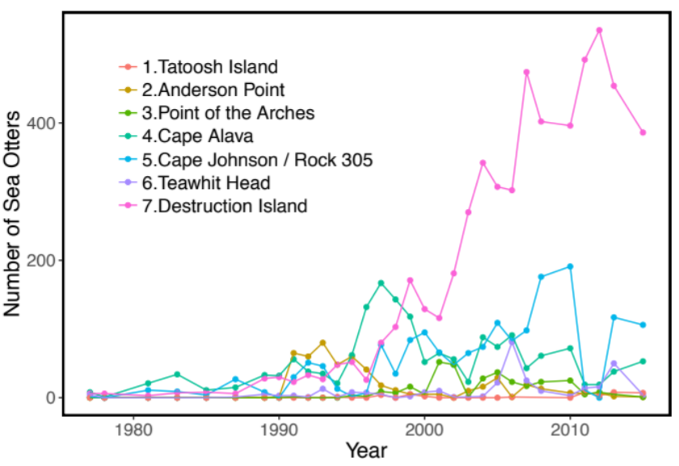
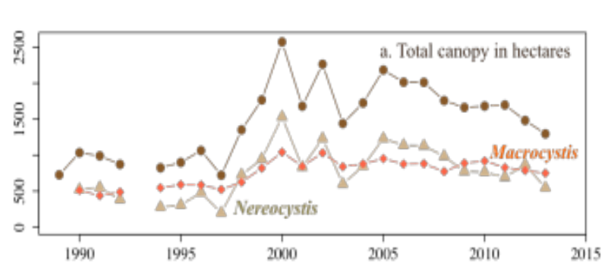
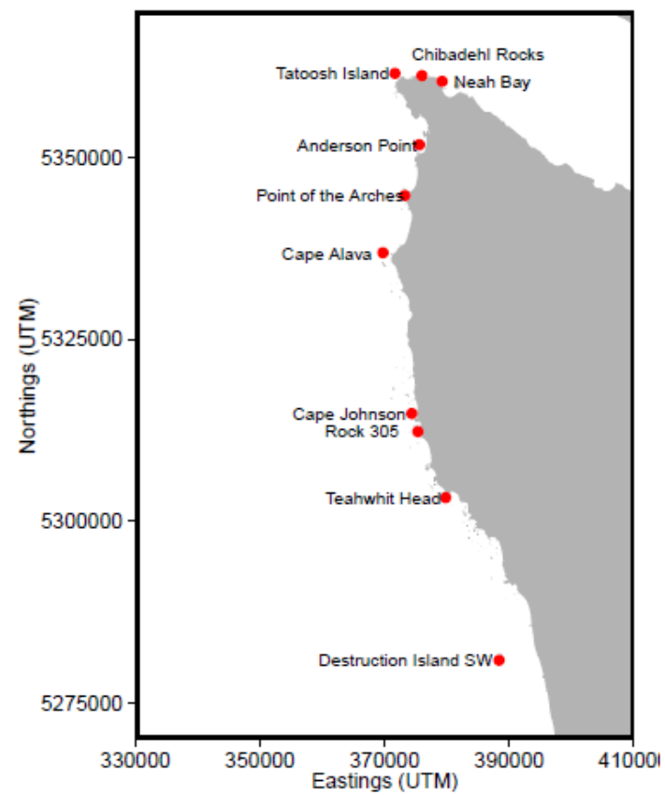
- Collect OCNMS wide values for otter abundance and kelp abundance since ~1990. These look like increasing trends. Essentially a sum of all of the lines on this figure:

Point is to motivate study. This study builds on Kvitek’s early studies and examines kelp forest communities substantially after a major shift – the reintroduction of otters.

- Increase in otters is not uniform coastwide.
Table 1. We can classify otter abundance into categories (otters common, otters moderate, otters rare, for example). Make a table, column heads site, mean otters, CV otters, category
Figure 2. We can use otter classifications to characterize kelp aggregate properties at a smaller spatial scale than coastwide. 3 panels. Kelp mean, CV, and mean vs CV, categorized by otters common, moderate, rare. Otters common has high mean kelp, otters moderate has moderate mean kelp, otters rare has low mean kelp. Point is to show that otters common and rare have low variability in kelp, but otters moderate have high variability in kelp, potentially in line with trophic cascade hypothesis.

KELP DATA FIGURE: “Mean Prop” means the average area with kelp cover out of the total area of benthos that is < 20m deep.
Plan to add colors to bars and points to correspond to the type of otter sites.

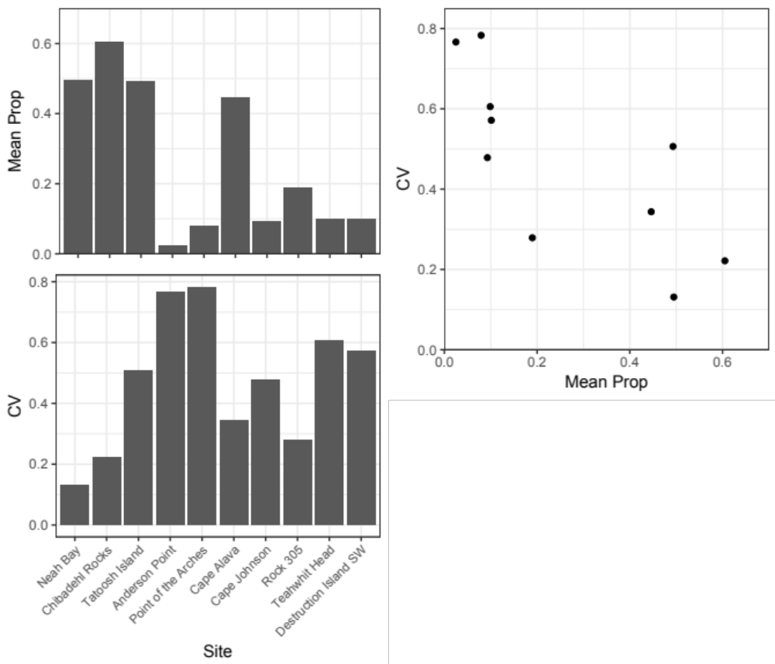

- We can move beyond these broad scale patterns to examine change at smaller scales. There is considerable variation at the site level in otter abundance: (Fig. 2). There is also considerable variation in kelp trends as well (something like one of Figs on next page)
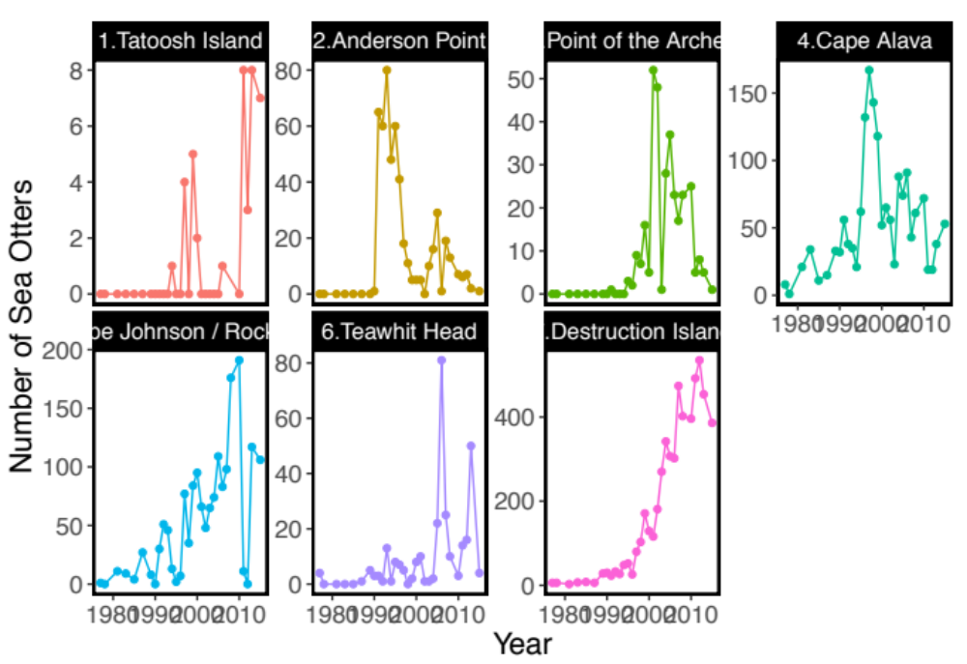
Analysis includes calculating pairwise cross-correlation between otters and kelp using a moving window and asking if the local patterns of correlation have changed over the years – in particular we are looking for a decline in correlation in recent years. We can also note the patterns of kelp vary strongly among sites and come up with some statistic for if the pattern of correlation in kelp among sites has change over the period.
Change raw areas of kelp to kelp as proportion of available habitat?

Regardless of the correlation patterns. Kelp data suggests the there has been a general decline at most of our sites. This motivates an examination of the classical reason for declines in kelp: invertebrate communities.
3 panels, Destruction, Neah Bay, Pt of Arches with time series of otters and kelp, representative of Table 1 categories. Cross correlation inset in corner
1 panel trend otters vs trend kelp, 2 windows (10yr, 20yr). kelp declining, otters ?. colored by otter categories from the Table
1 panel cross-correlation over time across all sites. weakening
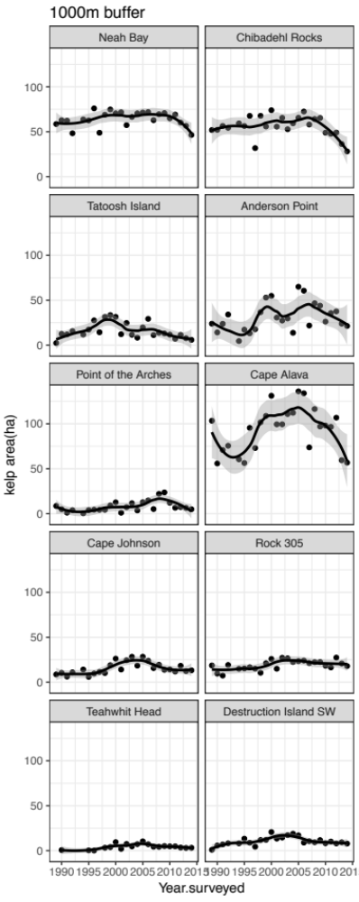
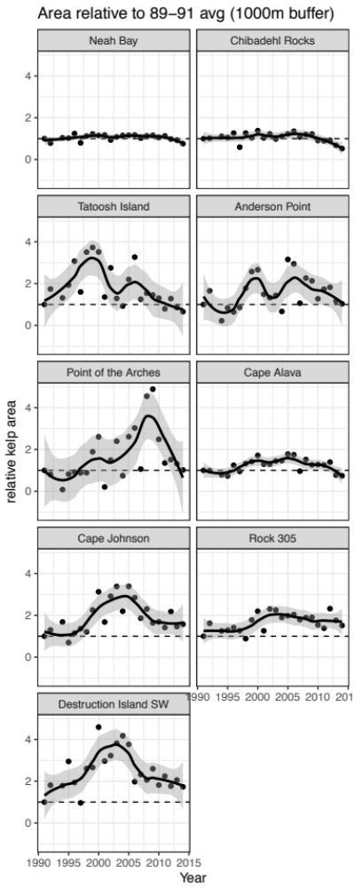

- Invertebrate Communities. Examine patterns for important species combining Kvitek and our surveys. Include Urchins, Sea Stars, Cucumbers, Crabs, Gastropods, Bivalves. One panel for each (perhaps only show 4?). Story here is that everything has declined since the 1987 dates.
There are some open questions about how to label things – e.g. should we use colors or shapes to indicate populations that didn’t have otters at parts of the time series. Or perhaps identifying different types of areas based on otter abundance (always otters, never otters, etc).

Otter prey community categorized by strong vs weak interactors (rows/panels), then within each row compare trends in prey between sites categorized by otter abundance a la Table 1

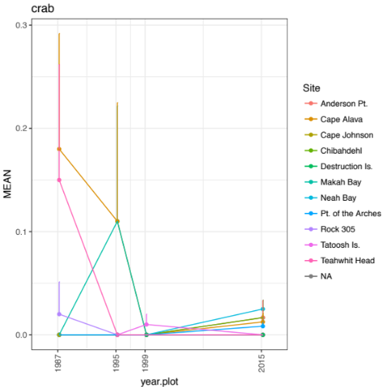
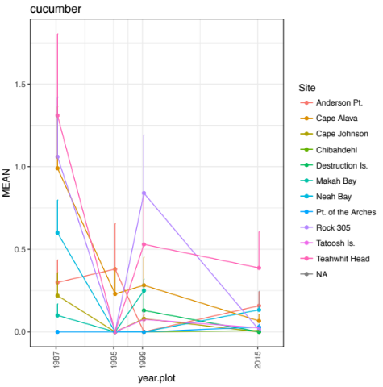
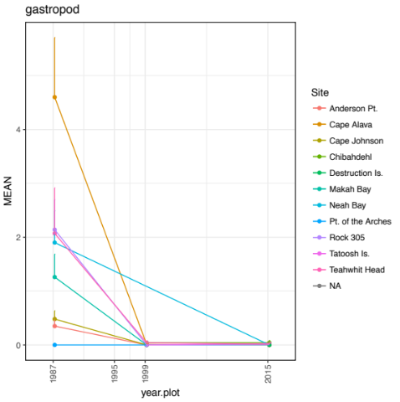
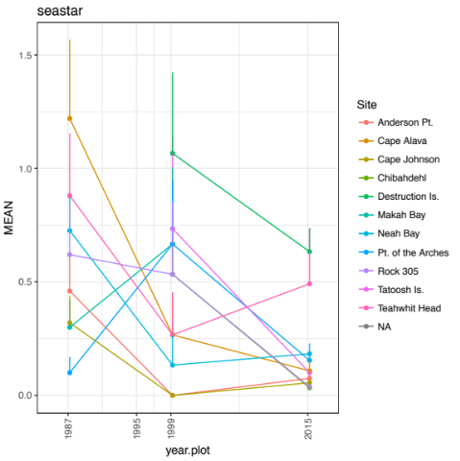
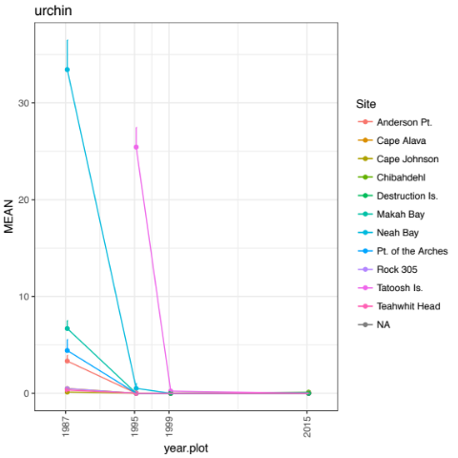

Finally there is a set of final figures. Current suggestion is that we use this part to examine community similarity of invert communities in a couple ways. One way is to compare similarity among recent years versus similarity among populations in 1987. Another is to look at similarity of communities by physical distance (e.g. are Destruction and Teahwhit more similar that Destruction and Neah Bay). Another is asking categorizing sites by their otter type (always present, never present, etc) leads to more similar communities.
We talked a bit about the possibility of doing kelp – oceanography correlations or regressions… but I think we agree that this is not the most interesting part.

I think this is the most open ended part of the paper to date and may change to some extent after some of the analyses come in.

